
phgy311
lecture #: | date: | professor:
8 | Sept. 22 | Dr. Cooper
9  10 | Sept. 25  Sept. 29 | Dr. Cooper  Dr. Cooper
announcements:
- Stay tuned for some awesome U2 events coming up in October, more details soon!!
- I’m still looking for a few writers for November, if you’re interested email me at phgy311ntcs@gmail.com
- Good luck to everyone on the quiz!

Edited By: Steph Rolin
Do Not Redistribute
set #3
September 22, 2006
PHGY 311: Lecture #8, Dr. Cooper
Writer: Anne-Laure Morin

REVIEW
- Note: lectures compliment the textbook, so do the chapter readings!
- We are trying to understand how an AP occurs, by studying the properties of ion channels.
  - We are using methods that are applicable to any channel.
- When the membrane is depolarized, sodium channels are activated very quickly. Sodium ions rush in, causing more channels to open. We hit the peak of the AP, where the sodium channels inactivate. Potassium channels are now open, which repolarizes (and actually hyperpolarizes) the cell.
- So, depolarization increases sodium conductance.
  - During the AP, sodium channels activate.
    - Sodium channels are measuring the changes of voltage.
- The more you depolarize the membrane, the more you open sodium channels.
  - Potassium channels also open with increases in voltage, but slower.
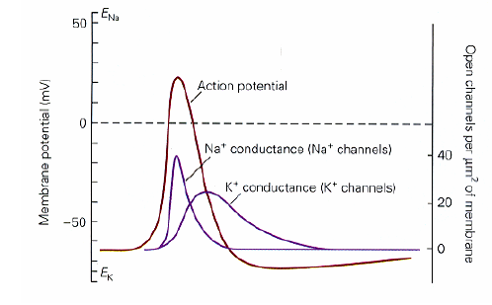
VOLTAGE CLAMP
- We want to vary the membrane potential, and measure at each level how the channels are responding.
  - Difficulty in doing so because the positive feedback system limits our ability to develop ideas.
- We need to use the voltage clamp, which prevents the membrane from generating an AP.
  - The voltage clamp injects current into the cell which is the mirror image of what is going through the channel.
    - Counterbalances ionic current.
- So the voltage clamp does two things:
  - Keeps the membrane constant,
  - Measures the ionic current.
- The voltage clamp amplifier compares the membrane voltage to the command potential.
  - If it deviates, a signal is sent to inject equal and opposite current.
- The only reason why the membrane potential would ever deviate from the command is by the ionic current.
  - We know that any change is due to the ionic current. We measure this change by how much current we must inject.
    - Exactly equal and opposite.
- The voltage clamp system is the technique one would use to measure any type of ionic current.
VOLTAGE CLAMP EXPERIMENT
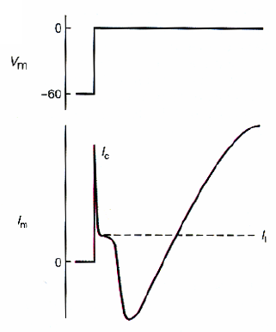
- NOTE: in these experiments, the first spike is an artifact. It is due to the initial injection of current that is necessary to change to membrane potential.
- We depolarize from -60 to 0mV.
  - VGSCs and VGPCs open.
    - The sodium channels are a function of voltage.
  - The graph on the right is a combination of the currents due to potassium and sodium. We want to separate them, and see how each conductance is affected by the change in membrane potential.
- So what we do is temporarily block either the sodium or potassium channels.
  - We use drugs or anesthetics to temporarily block these channels.
    - TEA (tetraethyl ammonium) blocks the potassium channels.
    - TTX (tetradoxin) blocks the sodium channels.
- The graphs below are the separation of individual currents due to potassium and sodium ions.
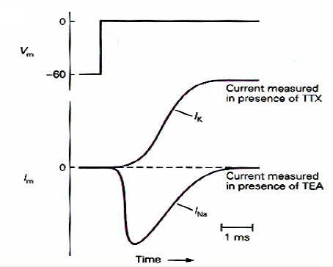
- So now that we can separate potassium and sodium, we can start varying the membrane potential, in incremental steps. (not separating Na/K currents below!)
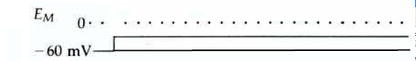
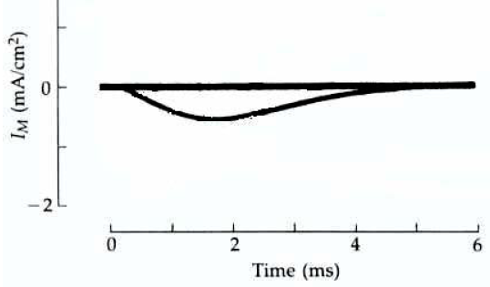
STEP 1: -60 TO -30mV
- There is some response. A relatively small current.
  - Negative deflection = positive ions entering = negative current.
- At this degree of depolarization, we’ve opened up some channels, but not many.
- This depolarization also has a slow time course.
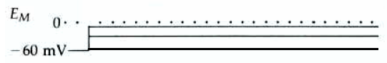
- We can open up a few channels with depolarization, but the probability that an individual channels opens increases with the amount of depolarization.

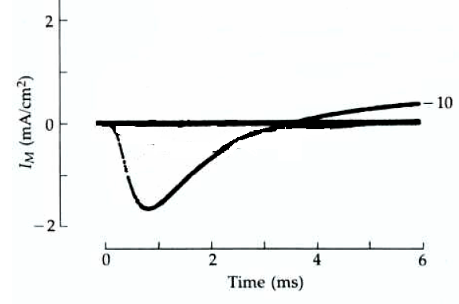
STEP 2: -60 TO -10mV
- This is a faster, larger current.
- At the end, there is a late phase, consisting of some outwards current, due to potassium channels.

STEP 3: -60 TO +10mV
- The channels are opening faster, but the amplitude is smaller.
- At the end of the pulse, there is a larger positive potassium current.
- Recall: 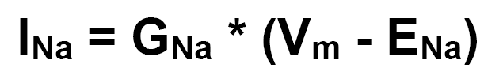
  - As we depolarize, we are increasing the conductance. However, we are also decreasing the driving force. When we change the step from -10 to +10mV, the increase in sodium conductance is not as large as the decrease in driving force.
    - We see a decrease in amplitude. The sodium current is smaller.
STEP 4: -60 TO +30mV
- The current is faster, but even smaller than before.
- There is no longer any change in conductance, we are at maximum. However, the driving force keeps getting smaller.
STEP 5: -60 TO +50mV
- There is no sodium entering.
  - We are almost are equilibrium, so there is no reason for it to enter.
- If we increase past +50mV, the gradient changes and sodium is actually pushed out of the cell.

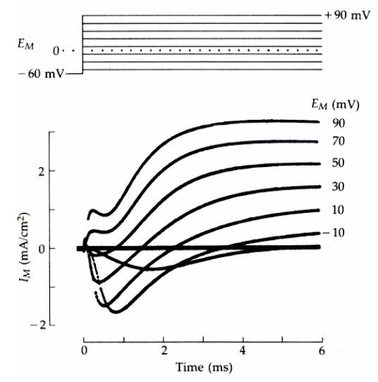

ANALYZING THE DATA
- How do we analyze this data to determine conductance?
- First, we plot the data and create a current/voltage graph.
  - We plot the peak negative voltage, to determine a relationship between membrane potential and sodium conductance.
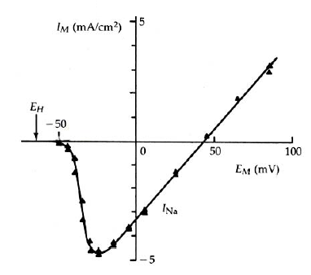
  - Next, we plot the potassium current/voltage graph.
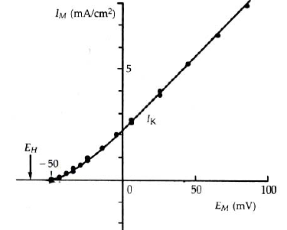

- However, we can’t really say what is happening to the channels.
  - What is the conductance doing? Our goal is to measure how conductance is changing as we vary voltage.
- We know I = g (V – E)
  - The driving force is a constant. So, conductance is equal to current, divided by a constant.
  - We plot our results and find that conductance is directly proportional to current.
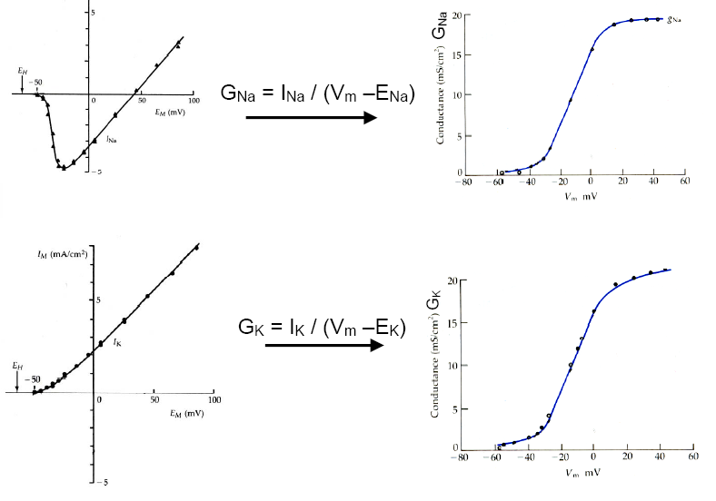
- As you depolarize the membrane, the conductance for these ions increases. We can actually find the voltage sensitivity of the channels.
- After +20mV, the sodium channels reach a maximum.
  - They are all open, and no matter how much more you depolarize the cell, you cannot open any more.
- The more you depolarize, the larger the conductance. That is because as you increase depolarization, you increase the probability that an individual channel opens.
- This is our conductance vs. voltage graphs. We see that the first step of an AP is voltage dependent.
  - Both VGSCs and VGPCs open more, as you depolarize more. They actually have a very similar relationship.
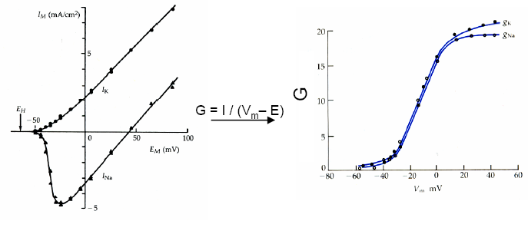
- But, even though the channels appear to be negating each other, we get APs anyway. This is because sodium channels respond very quickly! Potassium channels are slow.
  - We must plot the data with respect to time in order to see this.
- For every voltage step, we’ve converted current into conductance.
- Now, we plot the conductance/time graphs for sodium and potassium.
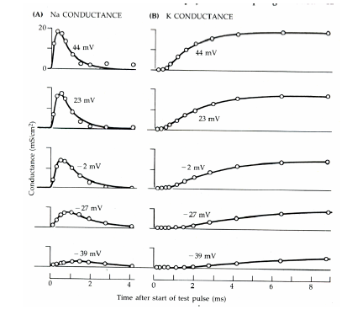
- Sodium channels activate. The voltage increases, we reach a peak, and then they inactivate.
  - Potassium shows no inactivation or real activity during this time scale.
So we can determine, for sodium, a time constant for activation and another time constant for inactivation, τa and τi .
  - The time courses it takes for these actions.
  - The rising phase is activation. Conductance increases. At the peak, the channels undergo inactivation. This follows an exponential time course, where τi is the time constant for inactivation.
- So we can clearly see on the above graphs that sodium channels activate much more rapidly.
  - At the peak of the sodium channels, the potassium channels haven’t responded yet.
- During repolarization, sodium channels are inactivated. A potassium current turns on and helps repolarization occur.
  - The voltage clamp experiment gives us a good idea of what’s going on.
- We have 3 steps, but following the AP, there is a refractory period.
  - Refractory period governs the frequency with which APs occur and propagate through circuits.
- We need to understand how VGSCs change from the inactivated to the resting state.

September 25, 2006
PHGY 311, Lecture 9
Dr. Cooper
Writer: Belinda Go

In Today’s Class:
- We will continue our discussion of the action potential and the voltage-gated channels that underlie the action potential.
- The reason why we are doing this is:
- to give us a clear understanding of the channels voltage-gated channels underlying the action potential, because that’s the definition of their excitability. The action potential is the important signal that flows through the neural circuit
- to allow us to understand almost any ion channel. The analysis that we go through is applicable to any ion channel, voltage dependent or neural transmitter gated, etc…
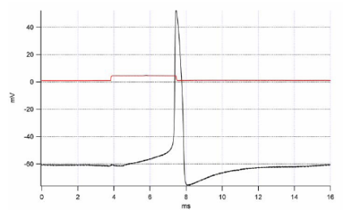
The Action Potential
- These channels undergo with membrane depolarization a conformational change, and we’re investigating these conformational changes by analysis with the voltage clamp

The Voltage Clamp Technique
- The advantages of the voltage clamp is:
  - To keep the voltage constant at any given level, so we can see how channels react at particular voltages
  - We can get a direct measure of the current that flows through the channels. This gives us a direct measure of what they are doing when they change their conformational states (closed, open, inactivated)
- In the voltage clamp experiment we can vary membrane potentials and probe the channel by measuring the currents that flow through the channel.
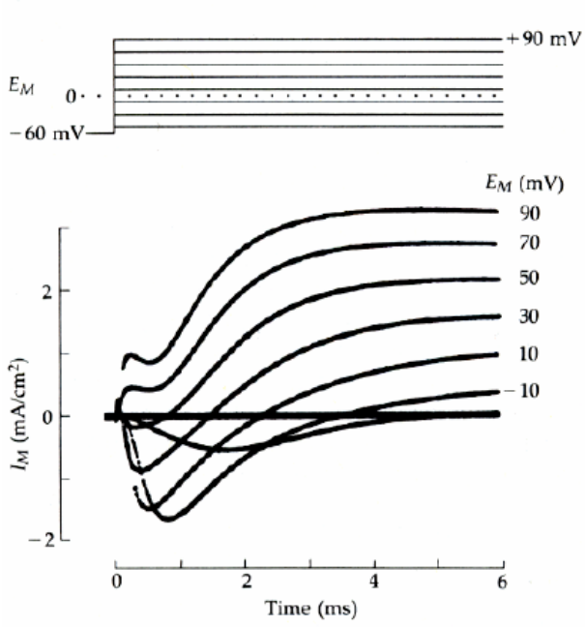
- When we do a voltage clamp experiment, we measure currents that look like this:

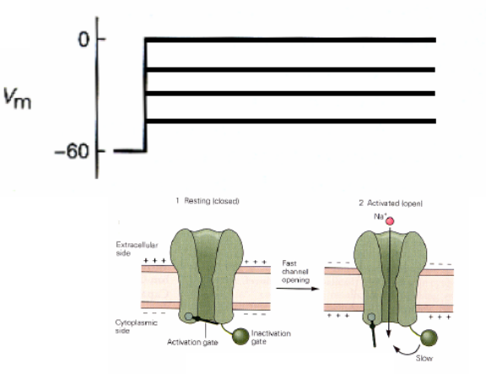

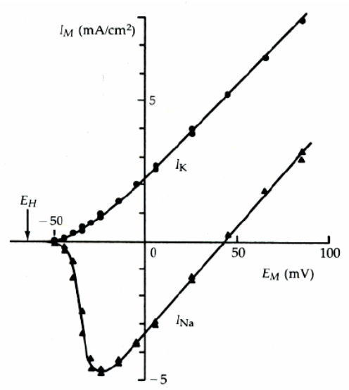
- These superimposed currents are responses to different levels of current.
- We have measurements of both the effects on the channel and the effects on the driving force in any experiment like this.

The Voltage vs. Current Graph
- The above data can be plotted into a curve of voltage and current.

Na+ current
- The first spike of the graph represents the voltage step for the depolarization of the membrane
- At first, when we depolarize, there’s a small inward current.
- As we keep depolarizing, the sodium current will get bigger
- Then after a certain point, the sodium current will get smaller.
- If we keep depolarizing, the sodium current will become positive (outward current)
- This graph is just the description of the data we get from the voltage clamp experiment.

K+ current
- As we depolarize the membrane further and further, the potassium current just gets larger and larger
  - The potassium conductance gets larger and so does the driving force.

Voltage Sensitivity of Channels
- From our voltage clamp experiments, we want to get a measure of how the sodium channels are responding.
  - In other words, we need to know conductance vs. membrane potential. It’s not obvious from the current that the Na conductance is increasing.
- To obtain the conductance, we just flip around the equation I = G x (Vm – E), so that it’s

- G = I / (Vm – E)

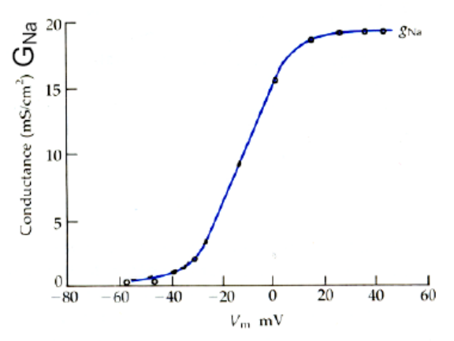
- This is a direct measure of the conductance.
    - The current (I) was measured through the voltage clamp experiment
    - Vm is the voltage step (clamp) that was varied
    - The ionic potential (E) is a constant term because the concentrations do not change
  - Thus the denominator (Vm – E) can be considered as a constant
- Using this equation, we can convert the IV curve to the conductance(G) vs. Voltage curve
- Therefore we can get the voltage sensitivity of the channel
- Here we can see that as the voltage depolarizes, the sodium conductance gets larger.
  - The conductances eventually plateaus when all possible channels are open (a saturation point).
- The curve would look very similar if we were measuring one single Na channel and depolarizing it, whereas here it is a curve that represents the probability of opening a Na channel
- This is what is called Activation by Voltage
  - It is a measure of the conformation change of the channel from a closed state to an open state
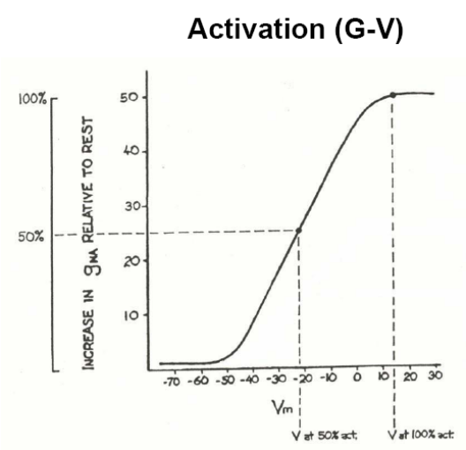
Activation Curve (G-V Curve)
- Applies to the Na channel and is true for ANY voltage gated channel
- It is the same sort of graph as above, shown in a different fashion.
- This graph measures the relative increases in sodium conductance as the cell depolarizes compared to the conductance at rest
  - We start off with a sodium conductance of 1. As the membrane depolarizes, conductance can increase up to 50 fold
- We look at the percent of the maximum, usually the halfway point
- This point known as V_{1/2} is the voltage needed to open 50% of the conductance channels
- This is what governs the voltage sensitivity of the channels (excitability)
- The more sensitive the channels are to voltage, the easier it is to fire off an action potential (i.e. less voltage is needed).
  - The steeper the curve → the more sensitive the channels are to voltage → less voltage is required to fire off an AP. And vice versa.

Kinetics for Opening of Channels
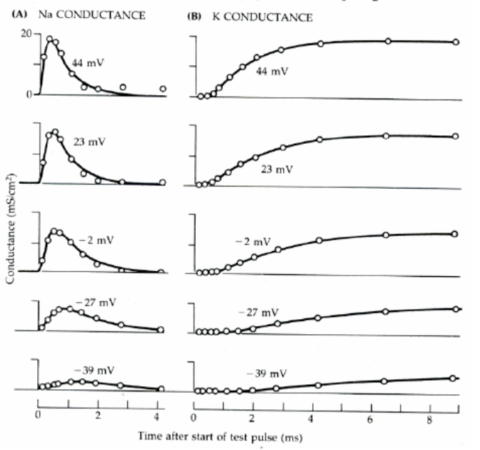
We’ve just measured how much voltage it takes for a channel to change from the closed conformation to the open conformation. But we’d also like to know how FAST (the kinetics) these channels can go from closed to open.

- We take the raw current data from the voltage clamp experiment, and divide the current by a constant (Vm – E) and plot it against time
  - This gives the time course for the conductance of sodium and potassium channels as we vary the voltage

- Important Points:
    - The more that we depolarize, the faster the kinetics for activation – speeds up for both K and Na
    - Na channels inactivate even though membrane potential has stayed constant, whereas K channels don’t
- How do we close the K channels that are not inactivated?
    - Repolarize the cell
  - They are gated by voltage, open with voltage, close without voltage
    - Not the case with Na channels, they close on their own by an intrinsic method

There are a number of differences and we can measure these kinetic parameters, both activation and inactivation from voltage clamp experiments.

- Note: We’ll get to this later, but just remember for now:
- Threshold depolarization occur around low levels
- Mainly Na channels opening:
  - At low depolarization, we get slow activation
  - As we increase the depolarization, activation of the channels speeds up.
- K channels are much slower to open. So at threshold, they are still in their resting state.
  - Sodium channels have opened and reached a high conductance before the potassium channels have even opened.

Kinetics of Inactivation of Sodium Channels
What else can we get from these curves?
- We can also get the time course for the sodium channel undergoing inactivation
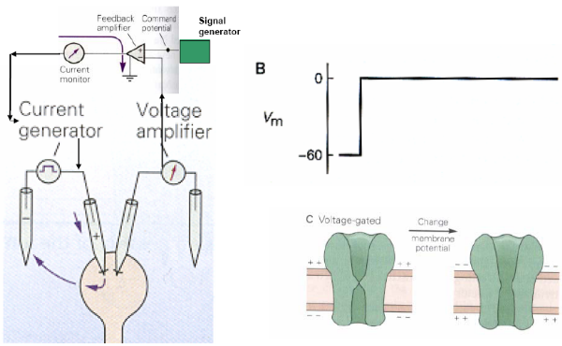
    - It’s given by the decaying phase of the curve

Summary of Voltage Clamp Analysis:
- Voltage dependent activation
- Kinetics for activation (For both Na and K channels)
- Kinetics for inactivation
- Increase in conductance of voltage through activation
- Measure of the inactivation of Na
- Activation of K
- Deactivation of K as the membrane potential falls
- From these measurements, we have a good idea what’s going on during the action potential

Kinetics of Repolarization of Sodium Channels
- Once we have an AP, the channel is in its inactivated state, how does it get back to the closed state so it can fire another action potential?
    - This is the whole key to the refractory period
  - We need to move from inactivated to closed state to be able to trigger a new AP.
    - Need to measure how long does it take for a channel to go from inactive to resting state.
  - The length of time is important because that’s what governs the refractory period (ex: the longer it takes, the longer the refractory period)
- We’d like to know the time course and the voltage sensitivity for this removal of inactivation (i.e. the repolarization phase)
- How can we distinguish between these twos state of the channel when Na ions cannot conduct through them, one is in inactivated and the other is closed (both have about the same negative membrane potentials)?
- First send a pulse of current sending them all into the same state
- Then give a second pulse to determine the difference by seeing how they respond

1. Time Course of Repolarization
- We can study the time course of repolarization by clamping the voltage twice
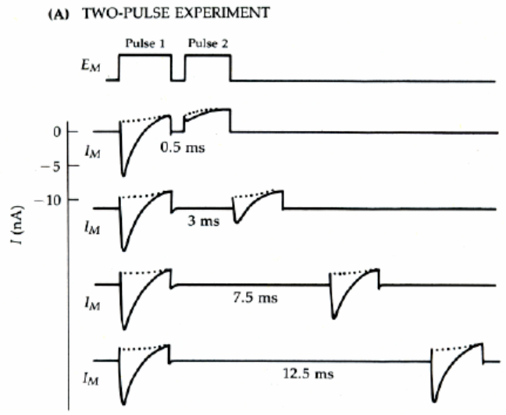
- It’s called the Two-Step protocol: the same depolarization is given twice, at different time intervals
  - The first depolarization is to get the channels to open and then go into the inactivation state.
  - The second is seeing if they are out of the inactivation state yet.
    - The inactivated channels will not respond to a second pulse, whereas channels that are in the closed state can open to depolarize again

The Two-Pulse Experiment for Na channels
- We fire one depolarization and wait varied lengths of time before firing the depolarization again
- If the second depolarization produces a sodium current, it means that a certain number of sodium channels have repolarized.

Results:
- If we wait very little (0.5ms) before firing again, then the sodium current is a fraction of the size after the second depolarization pulse.
  - This tells us that most of the channels are still inactive after 0.5ms.
  - They were inactivated by the first pulse, and 0.5ms is not enough time for many to recover
  - By estimating from the graph, about 5% of the channels have had a chance to recover
- If we wait a bit longer (3ms), we see that a few channels (~30-40%) have return to the resting state and can open again.
- If we wait even longer (7.5ms), then maybe about 60-70% of channels have gone from inactivation to rest
- If we wait till 12.5ms, then all the channels are back to work.
  - The longer you wait, the larger is the current of the second pulse, letting more channels get into the closed state.
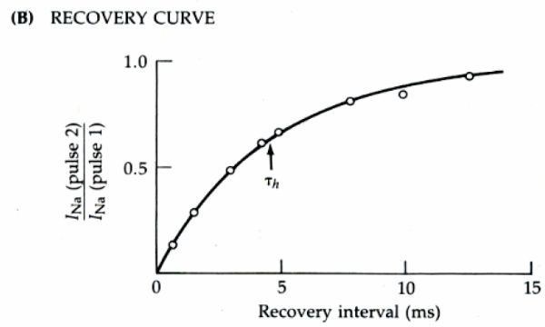
The Recovery Curve:
- From the results of this experiment, we can construct the recovery curve (follows a single exponential curve)
  - We are plotting the ratio of the second pulse to the first on the vertical axis
  - The horizontal axis is the interval between the pulses
  - We can see that at about 5 ms, two thirds of the sodium channels have recovered from their inactivation state.

- So this is how we obtained the kinetics for the removal of inactivation.
- But it turns out that the kinetics, the speed at which channels go from the inactive form to resting, also depends on the voltage of the membrane
  - At a more hyperpolarized level, the speed to remove inactivation is actually faster
- So not only does it take time, but also requires hyperpolarization to remove the inactivation
  - This explains why we always get an act of hyperpolarization after the action potential. The membrane potential always goes more negative then than the resting potential, and this extra negativity helps remove inactivation of Na channels so we can get a second burst of action potentials.
- If the action potential is very slow then the refractory period would be much longer, because the removal of activation would be a lot slower

2. Voltage Sensitivity during Repolarization
- We perform the Two-Pulse experiment again, except that this time we hold the membrane at different potentials.
- We send a first pulse to depolarize the membrane at a certain voltage and hold it there for a while.
- This allows us to see how channels return to the resting state after a certain period of time
- You then vary the membrane potential (set it to a new value) and send a second pulse (called the challenge pulse).
- Depending on the level of the membrane potential, there will be a population of channels that will be in the inactivated state and another population in the resting state. As you shift the membrane potential you change the population numbers.
- The higher the hyperpolarization level of the membrane, the larger the population of channels that will be in the resting state.

      - Test pulse
        - The test pulse starts at -65 mV and goes up to -21 mV.
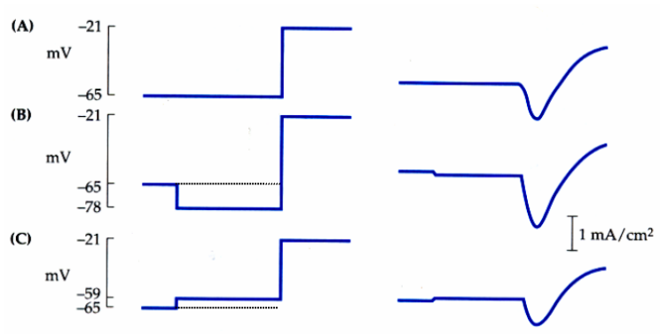
        - This allows us to measure the initial population of channels that are in the inactive and resting states.

      - Hyperpolarization
- Here we hyperpolarized the membrane.
- We change the membrane potential from -65mV to -78mV
  - So we hyperpolarized the membrane by -11 mV

      - When we depolarize the cell (we go back up to -21 mV), we see that we’ve shifted channels that were in the inactive state into the resting state.
          - Thus the resting state population has increased, while the inactive state population has decreased.

      - The current obtained by the test pulse is larger when the membrane is hyperpolarized
          - This because there are more Na channels that are activated/opened

      - Depolarization
- Here we depolarized the membrane. We changes the membrane potential from -65 mV to -59 mV
    - So we depolarized the membrane by 6 mV

    - When we send the challenge pulse (we depolarize the cell back up to -21 mV), we see that the channels have shifted from the resting state to the inactive state.
          - Thus the inactive state population has increased, while the resting state population has decreased.

    - The current obtained by the test pulse is smaller when the membrane is depolarized
          - This is because there are less Na channels that can activated/opened
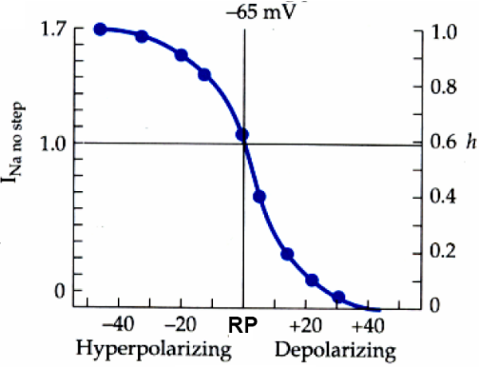
            - So the size of the current tells us the number of channels that can
respond

Membrane Potential (Vm) vs. Conductance (G) Curve
- Voltage is measured on the horizontal axis:
  - The resting membrane potential (-65mV) is referred as 0
- Sodium current is measured on the left vertical axis
  - The I_{Na} of the resting membrane is referred to as 1.0
- The conductance is measured on the right vertical axis
  - This parameter is called ‘h’
  - Referred to as the inactivation variable
  - It is measure in terms of percentage of the maximum number of channels

- As we hyperpolarize the membrane (going from zero to negative values):
  - The conductance increases (more channels are converted to the resting state)
  - The current increases as well, because there are more channels in the resting state that can be opened

- As we depolarize the membrane (going from 0 to positive values):
  - The conductance decreases (more channels are converted to the inactive state)
  - The current decreases as well, because there are fewer channels in the resting state that can be opened
  - If we depolarize by 30mV from rest, all the sodium channels will be inactivated (point at which the graph hits 0).
- At the resting membrane potential, about ~40% of channels are sitting in the inactivated state

- Steady State Inactivation
  - This is a highly non-linear curve; therefore if the membrane is depolarized by 20 mV, then 90% of the channels will be in the inactivated state.
  - This is a way to inactivate many of the sodium channels and in fact you can actually block the action potential from ever happening this way.
  - This method is termed “depolarization block”
  - The cell is being depolarized by some long stimulus to block action potentials by inactivating channels
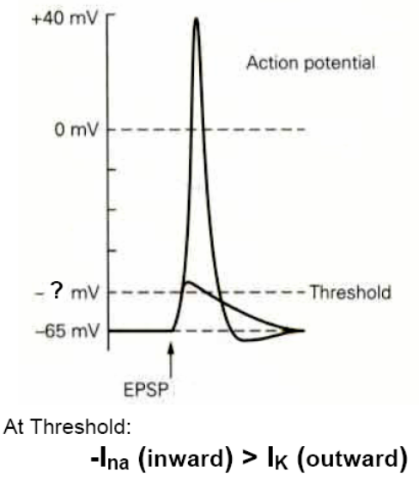
  - The same is true for the opposite – hyperpolarize membrane to fire quicker and more frequently

- Now we have a complete understanding of the sodium channels
- We understand their voltage sensitivities, kinetics, inactivation, and removal of inactivation.
  - Potassium channels work similarly to Na channels. We just don’t need to worry about inactivation because K channels only have opened and closed states

What is the threshold?
- Threshold is an all-or-none event.
    - If the depolarization in not large enough to reach threshold, no AP will be generated.
    - However once it is reach, an AP will always be generated.

- Threshold is the point at which enough sodium channels are open so that the positive feedback can occur.
- In other words, when the inward (Na) current is greater than outward (K)
- -I_{Na} > I_{K}

Definition of threshold: when inward sodium current is greater than the repolarizing potassium current.

- When inward sodium current outbalances outward potassium current,
we will go into the positive feedback loop.

- Therefore threshold depends on the conductance and driving force of sodium versus that of potassium channels
- Since the conductances can vary, causing the sodium current to vary, the threshold of the action potential varies.
- There is no fixed level of threshold for an action potential!
  - For example, it will be different at rest than when the channels are inactivated.

September 29, 2006
PHGY 311, Lecture 10
Dr. Cooper
Writer: Anne-Laure Morin

REVIEW
- Previously discussed topics:
  - Voltage clamp.
  - Kinetics of channels.
  - GV curves, IV curves
  - Inactivation, steady-state inactivation

- Today, we will focus on two things:
  - What is threshold?
  - What affects threshold.

THRESHOLD
- Threshold is the point at which the inward current exceeds the outward current.
  - INa [in]> IK[out]
- When this happens, the cell will enter a positive feedback loop, causing an AP.
- Conductance affects threshold.

EXAMPLE
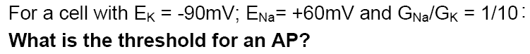
  - NOTE: We’re assuming no change in potassium conductance. However, we know that sodium conductance does depend on membrane voltage, so you cannot just sub these values in and solve for Vm.
  - First, let’s calculate the resting membrane potential.
    - As we’ve seen, it is -76mV.
  - Threshold is the point at which the inward current exceeds the outwards current.
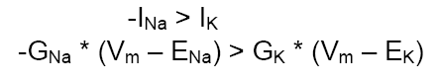
  - TRY 1: Vm = -50mV
    - We know potassium conductance, and the equilibrium potentials of potassium and sodium; we’re solving for the membrane voltage. We get sodium conductance off of the “G-V” curve for sodium.
      - Look at what the sodium conductance is when Vm=-50mV. We find that it increases to twice its resting value, so 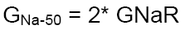
    - We have all our values, so:
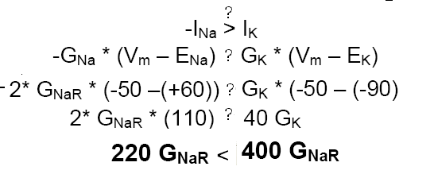
    - So this is BELOW threshold.
  - TRY 2: Vm = -40mV
    - We do exactly the same thing. Find
    - Find the sodium conductance off the graph.
      - Always express this in terms of Gna at rest.
    - We find this is above threshold. So, at a membrane voltage of -40mV, the inward current exceeds the outwards current.
  - TRY 3: Vm = -45mV.
    - We are trying to be more exact.
    - Actually -45mV is just below threshold. The actual threshold for this cell would be -44.5mV.
- Now, what happens to the threshold if we open chloride channels?

EXAMPLE
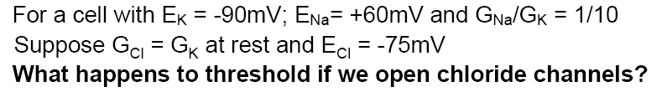
  - This is exactly the same problem, except now the outwards current consists of a chloride component and a potassium component.
  - Threshold will be at the point where:
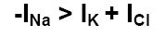
  - The resting membrane potential is still -76mV. We go through the same procedure, trying different values.
  - TRY 1: Vm = -45mV
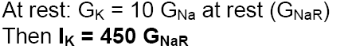

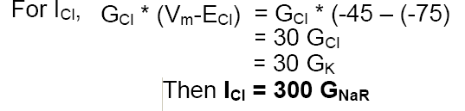

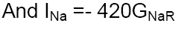

    - At this membrane voltage, the inward current does not exceed the outwards current. This is below threshold.

  - TRY 2: Vm = -40mV
    - This is just below threshold. We find threshold is actually -39mV.
    - So opening chloride channels increases threshold about 6mV.

REFRACTORY PERIOD
- So the threshold for an AP is variable.
  - We look at graphs find where the sodium current is opposite and larger than the potassium (and chloride, if applicable) current.
    - This is threshold.
- Refractory period is the period during which the threshold is changing.
  - Relative refractory period → where we can still generate a second AP but we need a much larger stimulus, the threshold goes up in Relative refractory Period
  - Absolute Refractory period → no matter what you do the inward INa is never greater than outward Ik

    - Immediately after the AP, Na channels inactivate and they take time (recovery) and this is directly related to refractory period. We need time to remove the inactivation.
    - When channels are not completely recovered, (ie some can be activated): for the properties of these channels the G-V relationship is exactly the same as before (you just don’t have as many channels as before)
- So what about during a refractory period?
  - Say 75% of sodium channels are inactivated after 4ms. Then, the normal sodium current needs to be 4 times as large (and opposite) to the outward current.
    - We only get a quarter of the expected depolarization as only a quarter of the channels that are normally open, are actually open.
- If potassium conductance also increases, this will never occur.
  - This is the absolute refractory period, as the sodium current will never exceed the force of the outward current. It is impossible to reach threshold.

